STA 291 Exam 1
2 October 2007
Name ___________________________________

Problem | Points
1
2
3
4
5
6
7
8
9
10
11
Total | /100

You are allowed pen or pencil and calculator.

STA 291 Exam 1 Page 2

1. Which of the following attributes is NOT categorical?
(a) a person's favorite type of pet
(b) your social security number
(c) the number of girls born at a hospital over a 6-month period
(d) a student’s letter grade for STA291

2. In a good graphical display of a categorical data set, which of the following should be proportional to the frequencies of the categories? Circle the correct answer(s).
(a) The central angles of sectors in a pie chart
(b) The heights of bars in a bar chart
(c) The areas of sectors in a pie chart
(d) The areas of bars in a bar chart
(e) The arc lengths of sectors in a pie chart

3. Below is a list of monthly normal high temperatures in Lexington, KY.
39 45 55 65 74 82 86 85 78 67 55 44
(a) Create a stem-and-leaf display for this data set.

(b) What is the median of the monthly normal high temperatures in Lexington?

(c) What is the range of the monthly normal high temperatures in Lexington?
STA 291 Exam 1 Page 3

4. A random sample of six UK Football fans is asked the following question. “What will be UK’s ranking at the end of this season?” The responses from the six fans are 10, 11, 10, 7, 13, 9.
(a) Calculate the three measures of central tendency that we have discussed in class.
(b) For each of the six students, calculate the deviation and the squared deviation. Then, use these six numbers to calculate the variance. The formula for the variance is given by the following formula.
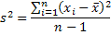
(c) Is the variance strongly affected by outliers? For example, if the first response of “10” was misrecorded as “70” – would that change the value of the variance a lot? You can answer this question without doing any calculations.
(d) Assume that a random sample of 100 UK Football fans would be asked the above question. Would you expect the distribution of the responses to be left-skewed, right-skewed, or symmetric? Justify your answer.
(e) Based on your answer in part (d), will the mean or the median of the responses be larger?
STA 291 Exam 1 Page 4

5. (a) Guess the correlation coefficient for the following scatterplot. Circle the correct answer.
-0.64 -0.44 -0.24 -0.04 +0.24

(b) Will the slope of the regression line (prediction equation) be positive, negative, or equal to zero?

(c) Will the y-intercept of the regression line be positive, negative, or equal to zero?

6. The National Weather Service records the maximum temperature for every day. The five-number summaries for the September 2007 data (until September 24) are
Lexington: 69, 79, 86.5, 90.5, 94
Louisville : 72, 85, 89.5, 93, 99
(a) Calculate the interquartile ranges for daily maximum temperature in Lexington and in Louisville.

(b) Is the data for Lexington left- skewed, right-skewed, or symmetric? Justify your answer.

(c) In Lexington, approximately what percentage of days had a maximum temperature of 90.5 and above?
STA 291 Exam 1 Page 5

7. (Circle the correct answer(s)). What could be a possible problem with using volunteer sampling?
(a) The sample will poorly represent the population.
(b) The results will produce misleading conclusions.
(c) The results will be biased.

The next two questions concern this situation: Do doctors in managed care plans give less charity care? Researchers chose 60 communities at random, then chose doctors at random in each community. In all, they interviewed 10,881 doctors. Overall, 77.3% of the doctors said they had given some care free or at reduced rates because of the patient's financial need in the month before the interview. Doctors who received at least 85% of their practice income from managed care plans were significantly less likely than other doctors to provide charity care.

8. The number 77.3% is
(a) a statistic, because it describes a sample.
(b) a statistic, because it describes a population.
(c) a parameter, because it describes a sample.
(d) a parameter, because it describes a population.

9. The sample in this study is
(a) all doctors who would say they have given some care free or at reduced rates
(b) all doctors
(c) the 77.3% of the 10,881 doctors who said they had given some care free or at reduced rates
(d) the 10,881 doctors interviewed

10. All of the following are features of a good statistical graphic except (circle any which apply):
(a) vertical scale that is compressed, or missing entirely
(b) many different shadings and colors that keep the eyes moving from item to item
(c) high ratio of “information to ink”
(d) use of “leading” captions to try to make the reader of the graphic come to the conclusion desired
STA 291 Exam 1 Page 6

11. The following table contains monthly unemployment rate data in one state for the past twelve months:
Month | 1 | 2 | 3 | 4 | 5 | 6 |  | 7 | 8 | 9 | 10 | 11 | 12
Rate | 7.5 | 7.6 | 7.5 | 7.3 | 7.2 | 7.1 |  | 7 | 6.7 | 6.4 | 6.5 | 6.3 | 6
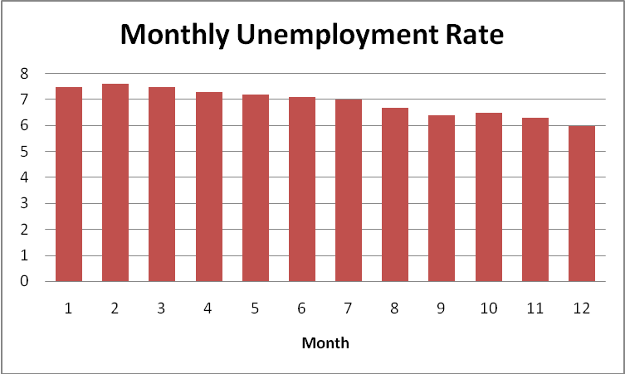 |  |  |  |  |  |  | 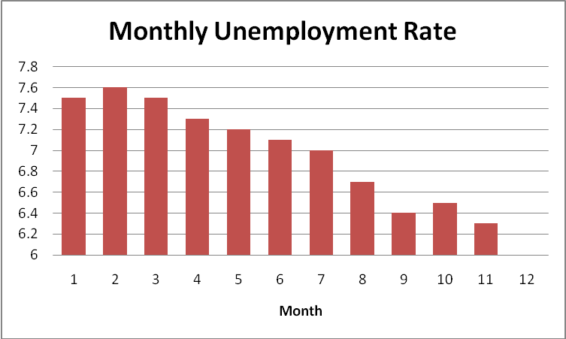

Both of the graphs were generated from those same data; the only difference is the vertical scale. Discuss the impression given by the two charts, for instance, if this state were holding an election for governor and you were the incumbent, which graph would be at least tempted to use? If you were the challenger? Which do you think most factually portrays the data?

