Information on CengageNOW for STA291 students

Hello STA291 students! I am Pamela Lancaster, the online STA291 coordinator. Cengage Learning provides a forum for online assessment that complements the text that we use, Statistics for Management and Economics, 8th Edition, by Gerald Keller. My job is to post online homework assignments for your class and assist you with any technical difficulties.
First on our agenda for online homework is to make sure that all STA291 students have a CengageNOW online account. There are a few things to keep in mind when setting up your account:
- Many of you will have purchased a new text that is bundled with an access code to the Cengage site. If you have not, then the UK Bookstore (and I believe Kennedy bookstore ) will sell you the online access code separately from the text. You may also purchase the code from ichapters.com; the product is: CengageNOW 2-Semester Instant Access Code for Keller's Statistics for Management and Economics, 8th Edition .
- If you have a STA291 CengageNOW account from the Fall or Winter 2008 semesters, it should still be active for this semester. Accounts from any other semesters will not work for this semester.
- Make sure that the product you purchase is NOT for WebCT, for Blackboard, for the 7th edition of Keller or directing you to the website ilrn.com.
- Please keep all documentation for CengageNOW online access (receipts, email, the access code itself, etc.).
- The CengageNOW technical support site: http://academic.cengage.com/tlsupport/customer/showStudent.do?custProductId=46 has a link for the “Student Smart Start Guide”. This provides steps on how to create your Cengage account. It also is a great resource for how to use your Cengage account and access homework assignments.
- When prompted to choose your school, make sure that you choose “University of Kentucky”. If you do not, you will have to contact Cengage technical support to fix it for you.
- The email address you use to sign-in will be the email I use to communicate with you, so you should use an account you check regularly.
- In the login process, there may be a place to enter a student ID. I never use this, so you may enter anything. I identify you via name and email address.
- Please view the computer specifications listed in “The Smart Start Guide for Students”. Note that if you choose to work on the Cengage site at home, work, etc., you will want to check the specs. I doubt we will need any audio or QuickTime, RealPlayer or the like, so these are not a vital as the other specifications listed. You will be using Java.
You may email me at pamela.lancaster@uky.edu if you have any questions/concerns.

To register as a new user:

1. Connect to the Internet and go to:
http://academic.cengage.com/login

2. Under New Users, click the Create My Account
button.

3. Click the Student button.

4. Enter your access code and click Continue. (The access
code came with your new textbook, or you may have
purchased it at the bookstore or online.)
Some access codes may redirect you to CengageNOW to
register. If you are redirected, please follow the
instructions, Help, and Start Smart Guide you find there
instead of these steps.

5. Enter your account information, select I accept for the
License Agreement, confirm your age, indicate your
message preferences, and click Continue. (Be sure to
record your e-mail address and password, as you will
need to enter them exactly when signing in.)

6. Indicate if your school is a U.S. or International
institution, and then use the Search tools to list it.

7. Select your school on the Search results list and click
Register. Your school is the “University of Kentucky”.
Your Dashboard page opens. Congratulations! You
have created your account.

8. To continue to CengageNOW, click the CengageNOW link
under Resources. (Note: The big arrow was put there by me for emphasis; it will not show up in your account.)

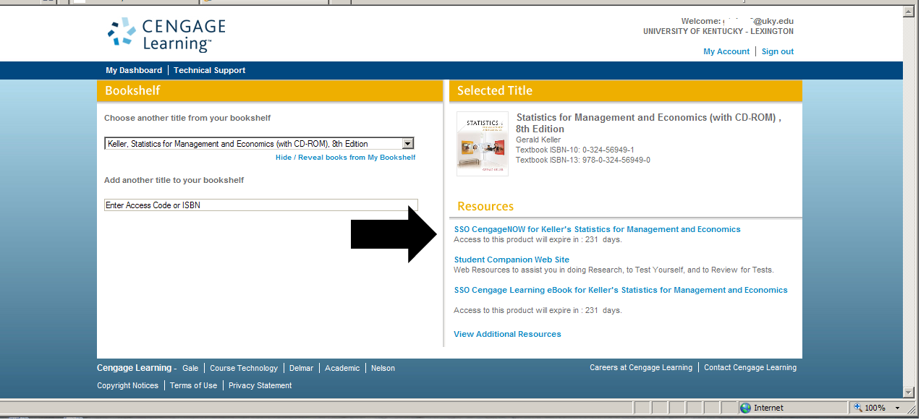

9. The next page confirms the creation of your
CengageNOW account. Verify your information, and
click Continue.
Your CengageNOW Home page opens.

10. Your instructor will have provided a Course Key; enter it in the
Register for Your Course box and click Submit.

