Practice problems for Exam 1

1.____ You take a random sample of 100 students at your university and find that their average GPA is 3.1. If you use this information to help you estimate the average GPA for all students at your university, then you are doing what branch of statistics?
a. | Descriptive statistics
b. | Inferential statistics
c. | Sample statistics
d. | Population statistics

2. ____ A company has developed a new computer sound card whose average lifetime is unknown. In order to estimate this average, 200 sound cards are randomly selected from a large production line and tested; their average lifetime is found to be 5 years. The 200 sound cards represent a:
a. | parameter.
b. | statistic.
c. | sample.
d. | population.

3.____ All calculations are permitted on what type of data?
a. | Interval data
b. | Nominal data
c. | Ordinal data
d. | All of these choices are true.

4.____ Which of the following statements about pie charts is false?
a. | A pie chart is a graphical representation of a relative frequency distribution.
b. | You can always determine frequencies for each category by looking at a pie chart.
c. | The total percentage of all the slices of a pie chart is 100%.
d. | The area of a slice of a pie chart is the proportion of all the individuals that fall into that particular category.

5._____ Suppose you measure the number of minutes it takes an employee to complete a task, where the maximum allowed time is 5 minutes, and each time is rounded to the nearest minute. Data from 130 employees is summarized below. How long did it take most employees to complete the task?

Time (minutes) | 1 | 2 | 3 | 4 | 5
Frequency | 15 | 30 | 40 | 25 | 20

a. | 5 minutes
b. | 3 minutes
c. | 40 minutes
d. | 20 minutes

6.______Which of the following represents a graphical presentation of interval data?
a. | A bar chart.
b. | A histogram.
c. | A pie chart.
d. | All of these choices are true.

7.______ Which of the following describes the shape of the histogram below?

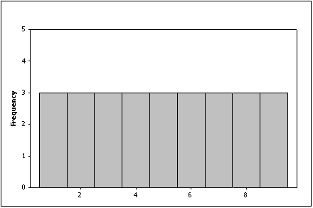

a. | Positively skewed
b. | Negatively skewed
c. | Symmetric
d. | None of these choices

8._____ What does the length of each line of a stem-and-leaf display represent?
a. | The percentage of observations in the interval represented by that stem.
b. | The number of observations in the interval represented by that stem.
c. | The total frequency of observations within or below that stem.
d. | The number of digits to the left of the decimal point.

9.____ In the following cross-classification table, how are gender and pet ownership related?

 | Own a pet | Don't own a pet
Females | 60 | 30
Males | 80 | 40

a. | The percentage of pet owners is higher for males than for females.
b. | The percentage of pet owners is higher for females than for males.
c. | The percentage of pet owners is the same for females and males.
d. | You cannot compare percentages for males and females since the total frequencies are not equal.

10._____Which of the following statistics is a measure of central location?
a. | The mean
b. | The median
c. | The mode
d. | All of these choices are true.

11._____ In a perfectly symmetric bell shaped "normal" distribution:
a. | the mean equals the median.
b. | the median equals the mode.
c. | the mean equals the mode.
d. | All of these choices are true.

12._____Which of the following types of samples is almost always biased?
a. | Simple random samples.
b. | Stratified random samples.
c. | Cluster samples.
d. | Self-selected samples.

Salesperson Ages

13. The ages (in years) of a sample of 25 salespersons are as follows:

47 | 21 | 37 | 53 | 28
40 | 30 | 32 | 34 | 26
34 | 24 | 24 | 35 | 45
38 | 35 | 28 | 43 | 45
30 | 45 | 31 | 41 | 56

{Salespersons' Ages Narrative} Draw a stem-and-leaf display of this data. What is the minimum and maximum age of the salespersons in this data set?

Car Buyers

Forty car buyers were asked to indicate which car dealer offered the best overall service. The four choices were Carriage Motors (C), Marco Chrysler (M), Triangle Auto (T), and University Chevrolet (U). The following data were obtained:

T | C | C | C | U | C | M | T | C | U
U | M | C | M | T | C | M | M | C | M
T | C | C | T | U | M | M | C | C | T
T | U | C | U | T | M | M | C | U | T

14. {Car Buyers Narrative} Construct a frequency bar chart of this data. Which car dealer came in last place in terms of overall service?

109.
Children

15. The following data represent the number of children in a sample of 10 families from Chicago: 4, 2, 1, 1, 5, 3, 0, 1, 0, and 2.

{Children Narrative} Compute the median number of children.

Answers:

1. ANS: B

- ANS: C
- ANS: A
- ANS: B
- ANS: B
- ANS: B
- ANS: C
- ANS: B
- ANS: C
- ANS: D
- ANS: D
- ANS : D

Stem | Leaf
2 | 144688
3 | 0012445578
4 | 0135557
5 | 36

The minimum age is 21 and the maximum age is 56.

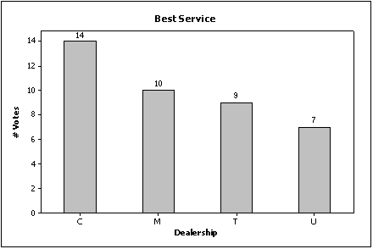

University Chevrolet (U) received the fewest votes for best overall service (7 out of 40, or 17.5%) and came in last place.

Median = 1.5

